IPL 2026 ANALYSIS

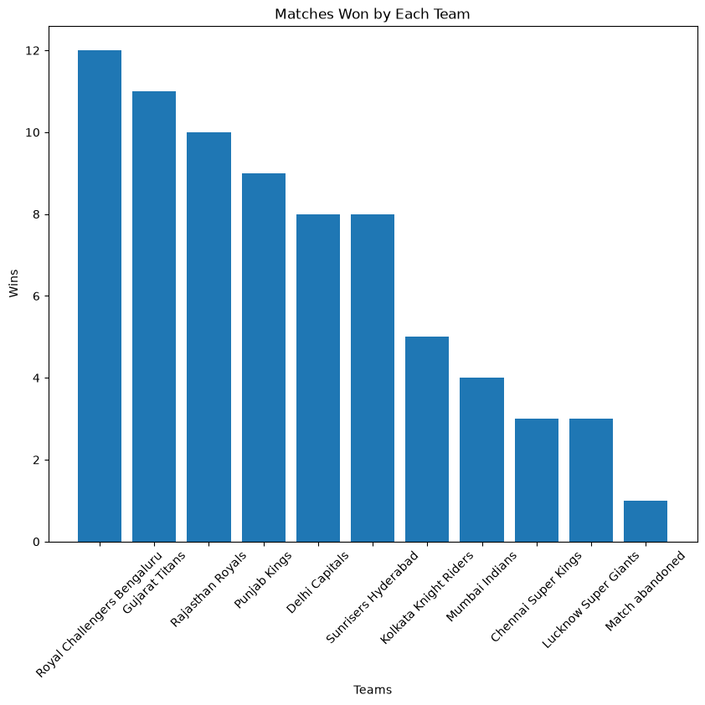

1. Matches Won by Each Team
The bar chart compares the number of matches won by each IPL franchise during the 2026 season. It highlights the overall performance of every team throughout the tournament. Teams with taller bars demonstrated greater consistency and success, while teams with fewer wins struggled to maintain momentum. This visualization provides a quick overview of the tournament standings and identifies the strongest performers.
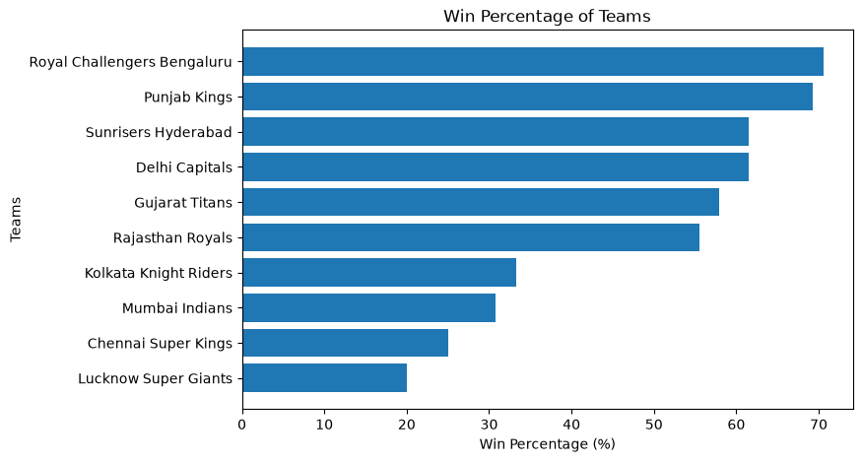

2. Win Percentage of Each Team
This horizontal bar chart illustrates the win percentage of every team by comparing matches won to matches played. Unlike total wins, win percentage accounts for the number of opportunities each team had, making it a more balanced measure of performance. Teams with higher percentages displayed greater consistency and efficiency over the course of the season.
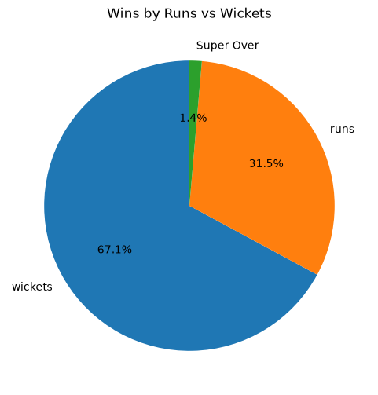

3. Distribution of Wins by Runs and Wickets
The pie chart represents the proportion of matches won by defending a target (runs) versus successfully chasing a target (wickets). This visualization helps determine whether teams generally performed better while batting first or while chasing. The distribution provides insights into overall match dynamics during the tournament.

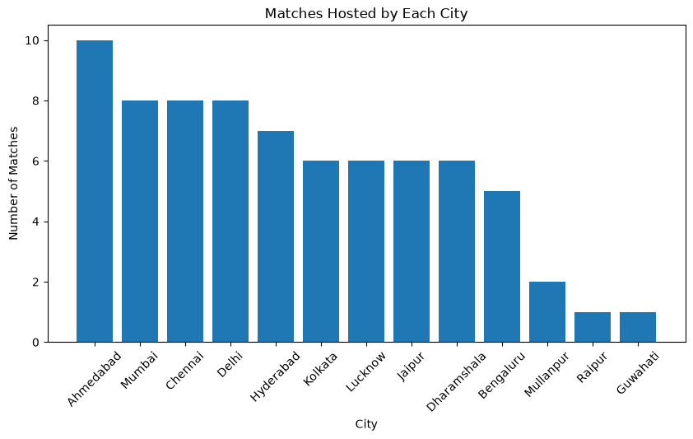

4. Matches Hosted by Each City
This bar chart displays the number of IPL matches hosted by each city. It highlights the cities that served as major venues during the season and provides an overview of the geographical distribution of matches. Cities hosting a larger number of games played a more significant role in the tournament schedule.

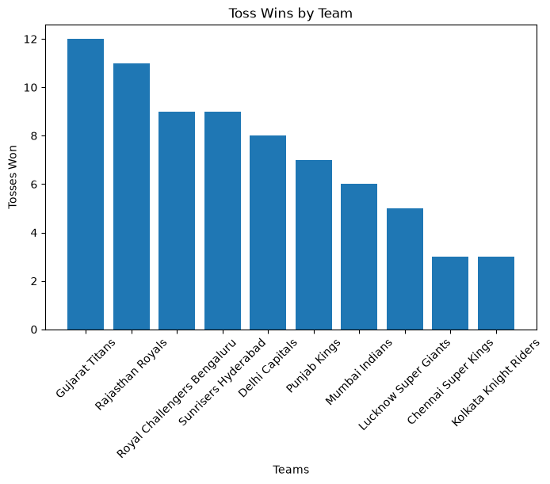

5. Toss Wins by Team
The chart compares the number of tosses won by each team throughout the tournament. Since the toss can influence match strategy, especially regarding batting or bowling first, this visualization helps examine whether every team had a relatively equal opportunity or whether certain teams experienced greater luck during the season.

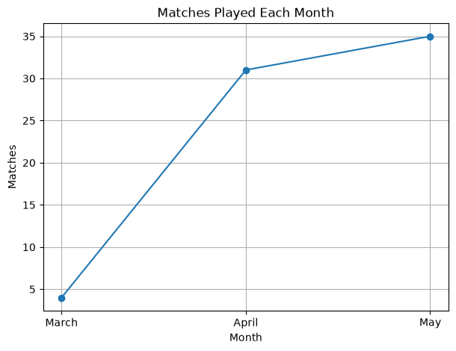

6. Matches Played Each Month
The line graph illustrates how the tournament progressed over time by showing the number of matches played each month. It highlights periods of increased match activity and provides a clear timeline of the IPL schedule. Peaks in the graph indicate months with a heavier fixture load.

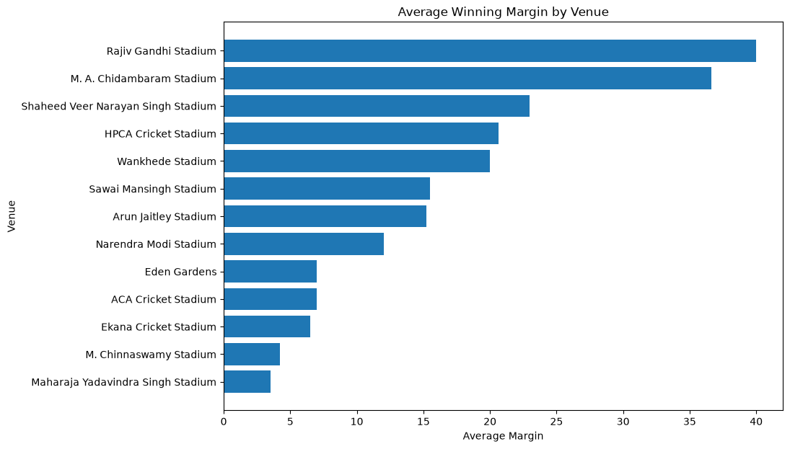

7. Average Winning Margin by Venue
This horizontal bar chart compares the average winning margin across all venues. Lower average margins indicate closely contested matches, whereas higher margins suggest more one-sided contests. The visualization helps identify which stadiums generally produced the most competitive games during the tournament.

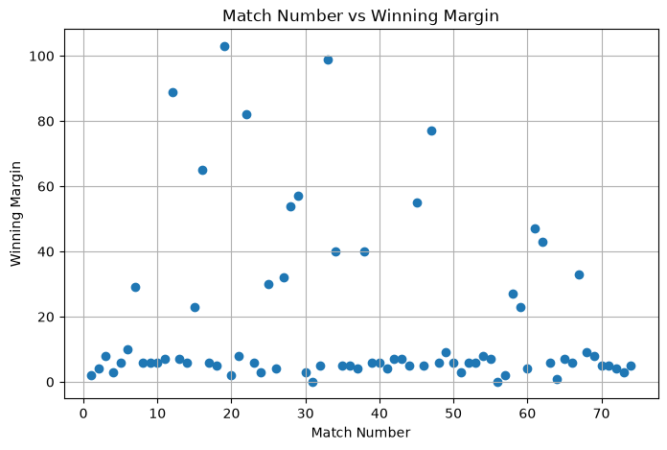

8. Match Number vs Winning Margin
The scatter plot examines the relationship between the match number and the winning margin. Since the points are widely scattered without forming a clear upward or downward trend, there is no strong relationship between the stage of the tournament and the size of victory. Large and small winning margins occurred throughout the season, suggesting that match competitiveness remained fairly consistent from the beginning to the end of the tournament.

